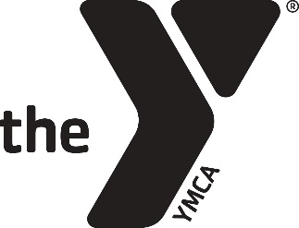

2016/17 YMCA BEFORE & AFTER SCHOOL
WEBSITE INFORMATION
BEFORE & AFTER SCHOOL WEBSITE LINK: www.indymca.org/youthdevelopment
BEFORE & AFTER SCHOOL BLURB:
For more than 30 years and in over 100 schools throughout the Greater Indianapolis area, the Y’s Before & After School program has been working with youth to boost their sense of achievement, relationships, and belonging, as well as keeping them safe during the critical hours when school is not in session. Our promise to you and your family is a safe and nurturing environment for your child to learn, be active, and grow. We are proud to currently offer multiple CCDF (Child Care Development Fund) certified locations, which allows families more options for child care assistance for fees, along with our internal Annual Campaign fund. Our goal is that no family is turned away due to the lack of ability to pay. Programs are available for Fall Break, Winter Break, Spring Break, weather delays and/or closings, and other scheduled or unscheduled school closings. For more information, visit our website at www.indymca.org or call 317.484.9622.

HIRING WEBSITE LINK: www.indymca.org/jobs
BEFORE & AFTER SCHOOL POSITIONS AVAILABLE:
Site Director
Assistant Site Director
Activity Leader

